6. Results, Analysis and Comparison
6.1 Overview of Experimental Evaluation
The experimental evaluation was conducted to investigate how different text representations, transformer architectures, model capacities and feature-fusion strategies affect phishing email classification performance. Rather than evaluating the models solely according to their final accuracy, the experiments were designed to examine the contribution of contextual language representations, explicitly engineered phishing-related features and different hybridisation strategies.
The experiments progressed from classical TF-IDF-based classifiers to pretrained transformer models and subsequently to hybrid architectures. The hybrid models combined contextual representations generated by a pretrained transformer with twelve handcrafted phishing-related NLP features. Additional experiments using smaller transformer backbones were conducted to determine whether the effectiveness of the hybrid approach was consistent across different model capacities.
All models were evaluated using the same held-out test set of 1,752 emails, consisting of 1,098 Safe Emails and 654 Phishing Emails. Overall Accuracy, Precision, Recall and F1-score were used for the principal model comparison. Phishing-class metrics and confusion matrices were additionally examined to provide a more detailed assessment of phishing detection and classification errors.
The analysis therefore focuses not only on which model obtained the highest score, but also on how and why performance changed when different representations and architectural configurations were introduced.

6.2 Overall Performance Comparison
Table 6.2.1 presents the overall performance of the evaluated models. Overall Precision, Recall and F1-score are reported using weighted averaging across the two classes.
Table 6.2.1: Overall performance of the evaluated models
Model | Accuracy | Precision | Recall | F1-score
TF-IDF + Logistic Regrassion | 97.98% | 98.44% | 96.13% | 97.27%
TF-IDF + Support Vector Machine | 98.72% | 98.62% | 97.94% | 98.28%
RoBERTa-large | 99.26% | 99.26% | 99.26% | 99.26%
DeBERTa-v3-large | 99.37% | 99.37% | 99.37% | 99.37%
ModernBERT-large | 99.37% | 99.37% | 99.37% | 99.37%
DistilBERT | 99.20% | 99.20% | 99.20% | 99.20%
TinyBERT | 97.09% | 97.09% | 97.09% | 97.08%
Concatenated Hybrid DeBERTa Model | 99. 37% | 99.53% | 98.77% | 99.15%
Gated Hybrid DeBERTa Model | 99.49% | 99.49% | 99.49% | 99.49%
Attention Pooling Hybrid DeBERTa Model | 99.32% | 99.31% | 99.32% | 99.31%
Gated Hybrid DistilBERT Model | 98.97% | 98.98% | 98.97% | 98.97%
Gated Hybrid TinyBERT Model | 96.00% | 96.14% | 96.00% | 96.03%
The results demonstrate that the transformer-based approaches achieved very high classification performance on the test dataset. Among the standalone transformer models, DeBERTa-v3-large and ModernBERT-large achieved the highest overall accuracy at 99.37%, followed by RoBERTa-large at 99.26% and DistilBERT at 99.20%. TinyBERT produced a lower overall accuracy of 97.09%.
The highest overall performance was obtained by the gated hybrid DeBERTa model, which achieved 99.49% accuracy, precision, recall and F1-score. Compared with the standalone DeBERTa-v3-large model, this represents an improvement of:
99.49 - 99.37 = 0.1299.49-99.37
= 0.12
or 0.12 percentage points in overall accuracy.
Although the numerical improvement is relatively small, this should be interpreted in the context of an already high-performing baseline. At an accuracy above 99%, only a small number of classification errors remain, meaning that further improvements are necessarily constrained by the limited number of incorrectly classified samples.
6.3 Text Representation and Model Capacity
The first experimental scenario examined the effect of using different types of text representations and transformer architectures.
The classical TF-IDF approach represents an email according to the statistical importance of its terms. While this representation is effective for identifying characteristic words, it does not explicitly model the contextual relationship between words.
Transformer architectures use self-attention to generate contextual representations, allowing information from different parts of an email to influence the representation of individual tokens. This is particularly relevant to phishing detection because words such as account, verify, payment or security may occur in both legitimate and phishing messages. Their significance can depend on the surrounding context and the overall structure of the message.
The strong performance of the transformer baselines is consistent with the ability of contextual representations to capture such relationships. DeBERTa-v3-large and ModernBERT-large achieved 99.37%, while RoBERTa-large and DistilBERT also achieved above 99%.
The lower performance of TinyBERT, at 97.09%, provides a contrasting result. TinyBERT has substantially lower model capacity than the larger transformer architecture evaluated in this project. Its lower performance suggests that the reduced representation capacity may limit its ability to capture some of the contextual patterns present in the dataset.
The model size should not be considered the sole explanation for this difference. The evaluated transformer models also differ in architecture, pretraining strategy and representation mechanisms.
Therefore, the results demonstrate a performance difference between the evaluated architectures rather than establishing a direct causal relationship between parameter count and accuracy.
An important observation is that the differences among the larger transformer models were relatively small. This indicates that once a sufficiently strong contextual representation was available, further differences in transformer architecture produced only marginal changes in overall classification performance.
6.4 Lightweight Transformer
The lightweight transformer experiments provide further insight into the relationship between model capacity and hybridisation. The results show that adding handcrafted phishing-related features did not consistently improve the performance of smaller transformer models.
DistilBERT achieved an overall accuracy of 99.20% when used as a standalone model, compared with 98.97% for its corresponding hybrid model. Similarly, TinyBERT achieved 97.09% accuracy as a standalone model, while its hybrid version achieved 96.00%. The performance reduction was therefore more noticeable for TinyBERT.
Table:6.4.1: Lightweight transformer comparison
Base Model | Standalone Accuracy | Gated Hybrid Accuracy
DistilBERT | 99.20% | 98.97%
TinyBERT | 97.09% | 96.00%
These results suggest that the additional feature branch did not automatically compensate for the lower representational capacity of the lightweight transformers. Instead, the effectiveness of hybridisation appears to depend on how well the handcrafted features complement the contextual representations produced by the underlying transformer. In the experiments, the hybrid strategy produced its strongest performance when combined with the larger DeBERTa-v3-large backbone.
This finding is important because it shows that hybridisation should not be assumed to be superior to a standalone transformer in every situation. The results indicate that the benefit of combining contextual and handcrafted features depends on the interaction between the quality of the underlying language representation, model capacity and additional feature information.

6.5 Handcrafted Phishing-Related Features
The next experimental scenario examined whether explicitly engineered phishing-related features could complement the contextual representations learned by the transformer. Twelve handcrafted features were designed to capture common characteristics found in phishing emails. These included urgency, credential requests, threats and authority, financial and payment-related language, calls to action, URLs, email addresses, telephone numbers, exclamation and question marks, uppercase-word usage, and text length.
The proposed hybrid architecture combines two sources of information. The transformer branch learns contextual patterns and relationships from the email text. The handcrafted feature branch provides explicit signals linked to common phishing characteristics. This combination allows the model to consider both the broader linguistic context and specific phishing-related indicators.
The comparison between DeBERTa-v3-large and the proposed Experiment 2 model provides clear evidence of the contribution of the additional feature branch. DeBERTa-v3-large achieved 99.37% overall accuracy, while the proposed hybrid model achieved 99.49%. The 0.12 percentage-point improvement shows that the handcrafted features provided additional useful information under the tested configuration.
The improvement is relatively small, which suggests that the transformer has already captured much of the information contained in the email text. The handcrafted features still contributed measurable information when integrated with the larger transformer representation. This supports the use of feature fusion as a complementary approach rather than treating handcrafted features as a replacement for contextual language modelling.
6.6 The Feature-Fusion Strategy
The hybrid experiments examined whether the method used to combine contextual and handcrafted features affected model performance. The experiments compared different fusion strategies while keeping the underlying DeBERTa-v3-large architecture consistent.
The initial hybrid architecture combined the two representations through feature concatenation. Experiment 2 extended this approach by introducing a learnable gated fusion mechanism. Experiment 3 added an attention-pooling step to refine the contextual representation before applying the hybrid fusion process.
In experiment 2, the contextual representation and handcrafted feature representation were first projected into a common 256-dimensional space. A sigmoid gate was then used to learn the relative contribution of each representation:
$$g=σ\left(w_{g}\left[h_{c};h_{f}\right]+b_{g}\right)$$
The final fused representation was calculated as:
$$h_{fused}=g ⊙ h_{c}+\left(1-g\right)⊙ h_{f}$$
This mechanism allows the model to learn how much contextual and handcrafted information should contribute to the final representation. It provides a more flexible combination than directly concatenating the two feature sets.
The results show a difference between the two fusion configurations. Experiment 2 achieved 99.49% overall accuracy, while Experiment 3 achieved 99.32%. This represents a difference of 0.17 percentage points in favour of experiment 2.
The result indicates that the choice of fusion strategies affected model performance under the evaluated conditions. The attention-pooling mechanism used in Experiment 3 did not improve performance compared with the gated fusion configuration.
The lower performance of experiment 3 may be associated with the additional attention-pooling step. The model first processed the transformer representation through attention pooling and then combined it with the handcrafted features. This extra processing did not produce a performance improvement in the evaluated experiment. Experiment 2 achieved higher accuracy with the gated fusion approach, suggesting that the simpler fusion process was more effective for this model configuration.
The experimentally supported finding is that the gated fusion configuration achieved stronger test performance than the attention-pooling configuration evaluated in this study.
6.7 Effect of Architectural Complexity
The effect of architectural changes within the hybrid modelling framework can be assessed by comparing the three hybrid experiments. Experiment 1 used direct feature concatenation and achieved an accuracy of 99.37% with an F1-score of 99.15%. Experiment 2 introduced gated fusion and increased both accuracy and F1-score to 99.49%. Experiment 3 added attention pooling to the transformer representation and achieved 99.32% accuracy and 99.31% F1-score.
The progression from Experiment 1 to Experiment 2 shows a measurable improvement following the introduction of gated fusion. Feature concatenation directly combines the transformer representation with the 12 handcrafted NLP features. Gated fusion extends this approach by introducing a learnable mechanism that regulates the contribution of the two feature sources before classification. The increase from 99.37% to 99.49% accuracy and from 99.15% to 99.49% F1-score indicates improved performance under the evaluated configuration.
Experiment 3 introduced an additional attention-pooling stage to refine the contextual representation before feature fusion. Its accuracy and F1-score were lower than those of Experiment 2, despite the additional architectural component. The results show that the increased processing of the transformer representation did not produce a corresponding improvement in classification performance.

Table 6.7.1: Comparison of Architectural Complexity and Performance
Experiment | Architecture | Architectural Complexity | Accuracy | F1-score | Description
Experiment 1 | Feature Concatenation | Moderate | 99.37% | 99.15% | Directly combining transformer and handcrafted features
Experiment 2 | Gated Fusion | Moderate | 99.49 | 99.49 | Combines transformer and handcrafted features through a learnable gating mechanism
Experiment 3 | Attention-pooling | High | 99.32 | 99.31 | Applies attention pooling to transformer representations before feature fusion
The comparison across the three experiments demonstrates that architectural complexity alone did not lead to higher performance. The results increased from feature concatenation to gated fusion but decreased when attention pooling was added. This highlights the importance of how transformers derived and handcrafted features are integrated rather than simply increasing the number of processing components.
6.8 Effect of Hybridisation Across Transformer Backbones
A further experiment evaluated whether the hybrid approach produced consistent benefits across different transformer backbones. Table 6.8.1 compares the standalone and hybrid accuracy of DeBERTa-v3-large, DistilBERT, and TinyBERT.
Table 6.8.1: Compares Standalone accuracy and Hybrid accuracy
Backbone | Hybrid Architecture | Standalone Accuracy | Hybrid Accuracy | Difference
DeBERTa-v3-large | Gated Fusion | 99.37% | 99.49% | +0.12%
DistilBERT | Gated Fusion | 99.20% | 98.97% | -0.23%
TinyBERT | Gated Fusion | 97.09% | 96.00% | -1.06%
The results show that hybridisation did not provide a uniform improvement across the three backbones. DeBERTa-v3-large increased from 99.37% to 99.49%, giving a 0.12 percent improvement. On the other hand, the hybrid versions of DistilBERT and TinyBERT dropped by 0.23 and 1.09 percent, respectively.
The findings indicate that the effectiveness of feature fusion is dependent on the underlying transformer backbone. DeBERTa-v3-large benefited from the additional handcrafted features, but the smaller backbones did not show the same improvement. The reduction in performance for DistilBERT and TinyBERT also indicates that adding a handcrafted feature branch does not inherently improve classification when the underlying representation is changed.
The observed performance demonstrates that hybridisation is backbone-dependent, with the strongest improvement occurring when the handcrafted features were combined with DeBERTa-v3-large.
6.9 Training and Validation Loss of Gated Hybrid DeBERTa Model
Training and validation loss provide an additional perspective on how the proposed model (experiment 2) learned from the data and how well its learned representations generalised to unseen validation samples. Training loss measures the difference between the model's predictions and the target labels on the training data, whereas validation loss measures the same objective on validation samples that were not used to update the model parameters.
Across the three training epochs, the loss values show a clear reduction in training errors. At Epoch 1, the training loss was 0.069629, while the validation loss was 0.057938. At Epoch 2, the training loss decreased substantially to 0.031458, with the validation loss also decreasing to 0.044775. By Epoch 3, the training loss had decreased further to 0.004025, while the validation loss was 0.043525. The training loss showed a consistent downward trend throughout training, while the validation loss improved substantially between Epochs 1 and 2 and then remained relatively stable between Epochs 2 and 3.
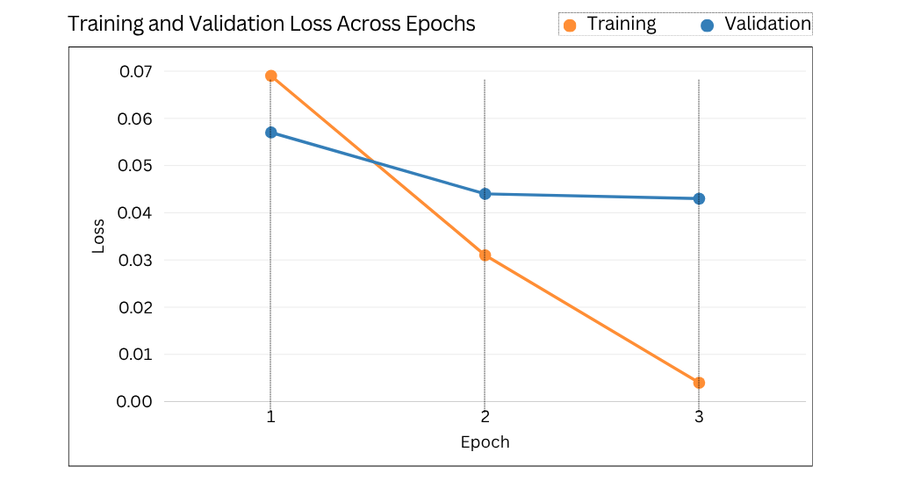
Figure 6.5.1: Training loss vs Validation loss
The lower training loss compared with validation loss is expected because the model parameters are directly optimised using the training data. The validation performance remained very high, indicating that the model retained strong predictive capability on data that was not used for parameter updates.
The final test evaluation subsequently produced an overall F1-score of 99.49%, providing evidence that the strong validation performance was not restricted to the training data.
The test set was kept separate from model development and was used only for final evaluation, ensuring that the final reported performance was measured on previously unseen data.
6.10 Phishing-Class Performance of Transformer Models
Although overall performance provides the primary basis for model comparison, phishing-class performance is particularly important because the main objective of the system is to identify phishing emails.
Table 6.10.1: Phishing-class performance
Model | Precision | Recall | F1-score
RoBERTa-large | 99.23% | 98.78% | 99.00%
DeBERTa-v3-large | 98.93% | 99.39% | 99.16%
ModernBERT-large | 98.93% | 99.39% | 99.16%
DistilBERT | 98.93% | 98.93% | 98.93%
TinyBERT | 97.04% | 95.11% | 96.06%
Gated Hybrid DeBERTa Model | 99.69% | 98.93% | 99.31%
Attention-pooling Hybrid DeBERTa Model | 99.23% | 98.93% | 99.08%
Gated Hybrid DistilBERT Model | 98.18% | 99.08% | 98.63%
Gated Hybrid TinyBERT Model | 92.20% | 97.55% | 94.80%
The results show that the larger transformer models generally maintained strong phishing-class performance. DeBERTa-v3-large and ModernBERT-large achieved the highest phishing recall at 99.39%, indicating that both models identified a very high proportion of the phishing emails in the test set. Their F1-scores were also high at 99.16%.
The hybrid models produced different precision and recall patterns across the transformer backbones. The DeBERTa-based hybrids achieved F1-scores of 99.31% and 99.08%, with precision values of 99.69% and 99.23%, respectively. The DistilBERT Gated Hybrid achieved the highest recall among the hybrid models at 99.08%, but its lower precision of 98.18% resulted in an F1-score of 98.63%.
A larger difference was observed for TinyBERT. The standalone model achieved 96.06% F1-score, while its gated hybrid achieved 94.80%. Its precision also decreased from 97.04% to 92.20%, despite an increase in recall from 95.11% to 97.55%. This result shows that adding handcrafted features did not produce a consistent improvement across all transformer backbones.
Overall, the class-specific results demonstrate that the models achieved different balances between precision and recall. DeBERTa-v3-large and ModernBERT-large provided the highest phishing recall, while the DeBERTa-based hybrid configurations produced strong precision and F1-score results. These differences provide a more detailed view of model behaviour than overall accuracy alone.
6.11 Confusion Matrix and Error Analysis
The confusion matrix provides a detailed view of the classification errors produced by the DeBERTa Gated Hybrid Model. As shown in Figure 6.11.1, the model correctly classified 1,096 safe emails and 647 phishing emails. Only two safe emails were incorrectly classified as phishing, while seven phishing emails were classified as safe.
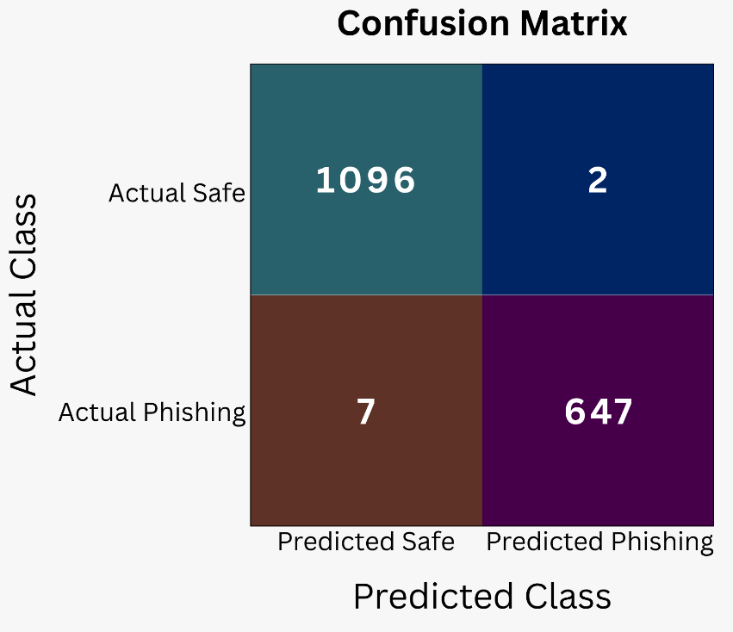
Figure 6.11.1: DeBERTa Gated Hybrid Model Confusion Matrix
The low number of misclassified emails demonstrates that the model maintained strong classification performance across both classes. The seven false negatives are particularly relevant to the phishing detection task because these emails were not identified as phishing. The two false positives represent safe emails that were incorrectly flagged as phishing. These results complement the precision, recall and F1-score analysis by showing the actual distribution of correct and incorrect predictions.
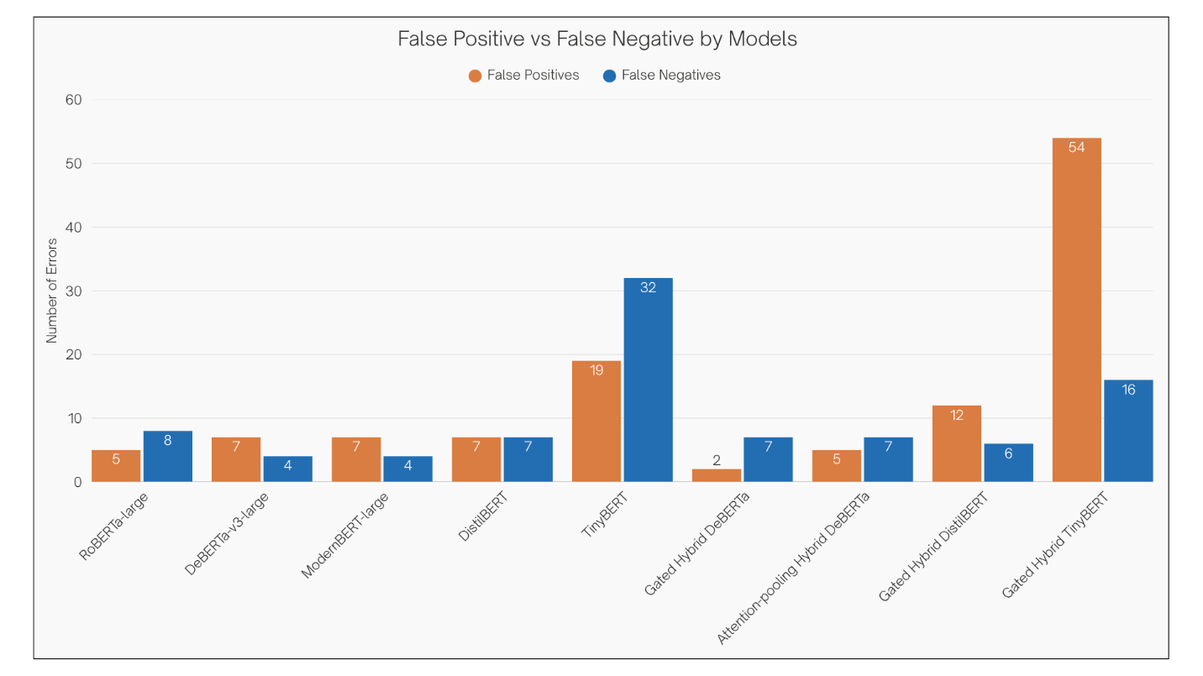
Figure 6.11.2: Comparison of False Positive and False Negative
It compares the number of false positives (FP) and false negatives (FN) produced by each evaluated model. False positives represent legitimate emails incorrectly classified as phishing, and false negatives represent phishing emails incorrectly classified as legitimate. Gated Hybrid DeBERTa Model recorded the lowest number of false positives, with only two cases, while DeBERTa-v3-large and ModernBERT-large achieved the lowest number of false negatives, with four cases each. TinyBERT Hybrid produced the highest number of false positives (54), indicating a greater tendency to misclassify legitimate emails as phishing. These results highlight the trade-off between reducing false alarms and preventing phishing emails from being missed.
6.12 Comparison with Existing Work Using the Same Dataset
To provide a more meaningful evaluation of the proposed model, its performance was compared with studies that used the same “zefang-liu/phishing-email-dataset”. Using a common dataset provides a closer reference point than comparisons with studies based on different phishing corpora, although differences in preprocessing, data splits, training configurations and evaluation protocols must still be considered.
A Robust and Explainable Transformer-Based Framework for Phishing Email Detection directly used the “zefang-liu/phishing-email-dataset”, which contains approximately 18,650 email samples. The study applied a stratified 70% training, 15% validation and 15% test split and fine-tuned DistilBERT for binary phishing classification. Its baseline DistilBERT model achieved 98.0% accuracy on clean test data. (Sajad U P 2026)
Evaluating the Effectiveness of LLMs and ML reported in Algorithms evaluated several traditional machine-learning and transformer-based models using publicly available phishing email datasets, including the same Hugging Face dataset. Its DistilBERT model achieved 98.44% accuracy, 97.71% precision, 96.86% recall and 97.28% F1-score on the imbalanced email dataset. The study also evaluated traditional models, with Random Forest achieving 99.47% accuracy and 99.08% F1-score on the same imbalanced email evaluation. (Tarapiah et al. 2025)
A recent study Classical-First Selective Cascades for Resource-Constrained Phishing Email Detection used “zefang-liu/phishing-email-dataset as its primary dataset”. After cleaning, the study retained 18,634 emails and evaluated a range of classical and transformer-based approaches. Its fine-tuned DistilBERT reference achieved an F1-score of 96.1%, while its TF-IDF and Linear SVM configuration also achieved approximately 96.1% F1-score on the held-out dataset. (Alajaji 2026)
The proposed models produced higher measured results under the experimental configuration used in this project. DeBERTa-v3-large achieved 99.37% accuracy and F1-score, increasing to 99.49% after integration with the 12 handcrafted phishing-related features. The proposed hybrid model also achieved 99.49% precision and recall. These results are summarised in Table 6.12.1.
Table 6.12.1: Comparison with existing work on the same dataset
Study | Model | Accuracy | F1-score
Robust & Explainable Transformer Framework | DistilBERT | 98.00% | _
Evaluating the Effectiveness of LLMs and ML | DistilBERT | 98.44% | 97.27%
Classical-First Selective Cascades | Fine-tuned DistilBERT | _ | 96.1%
Classical-First Selective Cascades | TF-IDF + Linear SVM | _ | 96.1%
Ours | Base DeBERTa-v3-large | 99.37% | 99.37%
Our proposed model | Gated Hybrid DeBERTa Model | 99.49% | 99.49%
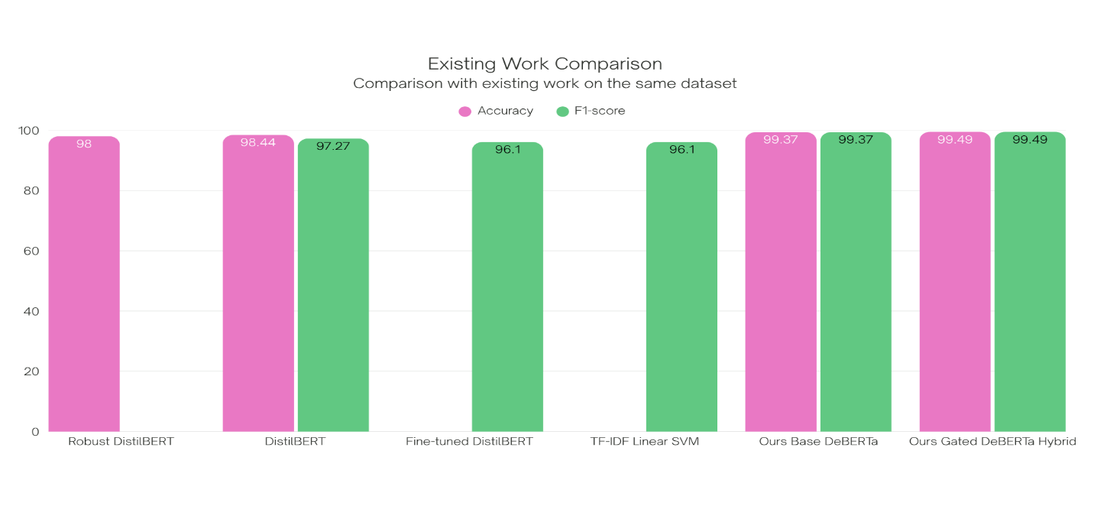
Figure 6.12.1: Existing Work Comparison
Existing studies using the same dataset reported strong results with both transformer and classical approaches. These results provide a useful benchmark for the proposed approach, although differences in preprocessing and evaluation settings limit direct comparison. The findings demonstrate that the dataset supports effective phishing detection using both traditional and transformer-based methods.
6.13 Discussion of Findings
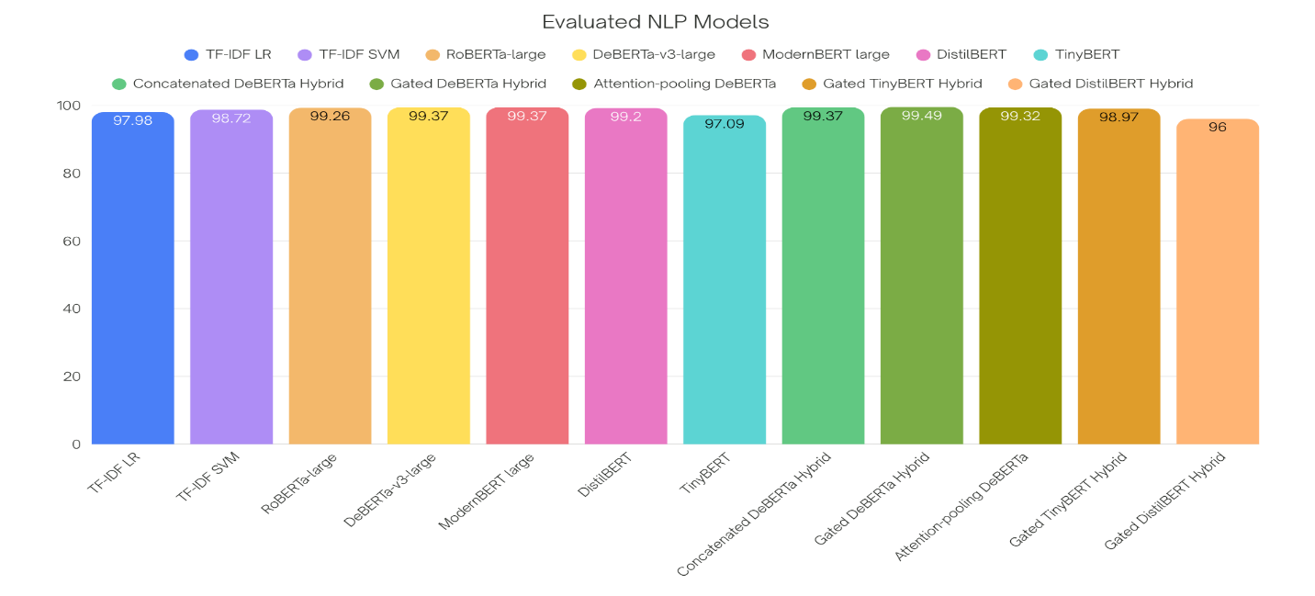
Figure 6.13.1: Discussion of Findings
The results provide several insights into the behaviour of the evaluated classification approaches. The classical TF-IDF models established a strong baseline, with Logistic Regression achieving 97.98% accuracy and SVM improving this to 98.72%. The transformer models produced further improvements, with the larger architectures achieving accuracy above 99%.
Among the transformer models, DeBERTa-v3-large and ModernBERT-large both achieved 99.37%, showing only a small performance difference between the stronger contextual representations. The effect of feature integration varied across the backbones. The DeBERTa-based hybrid improved from 99.37% to 99.49%, while the DistilBERT and TinyBERT hybrid models showed lower performance than their standalone versions.
The fusion strategy also affected the results. Experiment 2 achieved 99.49%, compared with 99.32% for Experiment 3, showing that additional architectural complexity did not necessarily improve classification performance.
The final confusion matrix of Experiment 2 contained nine classification errors, including seven false negatives. This indicates that some phishing emails were still classified as legitimate and highlights an important limitation for security-focused detection.
The findings show progression from strong TF-IDF based classification to improved contextual modelling with transformers, with the results influenced by the choice of backbone, feature integration and fusion strategy.
6.14 Experimental Findings
The experimental evaluation identified several key patterns across the classical, transformer-based and hybrid models. The findings highlight differences in baseline performance, the influence of model architecture and the effect of incorporating handcrafted phishing-related features. The main findings are summarised in Table 6.14.1.
Table 6.14.1: Summary of Experimental Findings
Finding | Experimental Result | Discussion
Classical models provided a strong baseline | TF-IDF + Logistic Regression: 97.98% accuracy, TF-IDF + SVM: 98.72% | Classical TF-IDF models provided a strong reference point for evaluating the transformer approaches.
Larger transformers achieved stronger performance | Larger transformer models achieved above 99% accuracy, while TinyBERT achieved 97.09% | The results indicate a performance difference between the larger and lightweight transformer architectures.
Handcrafted features added complementary information | DeBERTa-v3-large: 99.37%, Experiment 2 Gated DeBERTa: 99.49% | The handcrafted phishing-related features provided additional information when combined with the DeBERTa representation.
Fusion strategy affected performance | Experiment 2 Gated DeBERTa: 99.49%, Experiment 3 Attention-pooling DeBERTa: 99.32% | The evaluated gated-fusion configuration performed better than the attention-pooling configuration.
Greater complexity did not improve performance | Experiment 3 introduced additional attention processing but achieved a lower result than Experiment 2 | Additional architectural components did not produce a corresponding performance improvement.
Hybridisation depended on the transformer backbone | DeBERTa hybrid improved performance, while DistilBERT and TinyBERT hybrids decreased | The effect of handcrafted feature integration varied according to the underlying transformer architecture.
Multiple metrics were needed for evaluation | DeBERTa-v3-large and ModernBERT-large had higher phishing recall, while Experiment 2 had higher phishing precision and F1-score | Accuracy alone does not fully describe the behaviour of a phishing detection model.
Errors remained despite high overall performance | Experiment 2 produced 2 false positives and 7 false negatives from 1,752 test emails | The model achieved high overall performance but still misclassified a small number of emails, including phishing emails classified as legitimate.
6.15 Final Model Selection
Based on the controlled experimental evaluation, Gated Hybrid DeBERTa Model was selected as the final model. The model achieved 99.49% accuracy, precision, recall and F1-score, with 9 incorrect classifications out of 1,752 test samples.
For the Phishing Email class, the model achieved 99.69% precision, 98.93% recall and 99.31% F1-score. The results also showed that the gated fusion architecture provided stronger overall performance than the other evaluation in this project.
Model selection was based on the combined results across overall classification performance, phishing-class performance, confusion-matrix analysis and architectural comparisons. Under the experimental conditions of this project, Experiment 2 - DeBERTa Gated Hybrid provided the strongest overall balance between the evaluated performance measures and was therefore used as the final model for the subsequent stages of the project.
6.16 Limitations of the Results
The results should be interpreted within the scope of the experimental design and evaluation conditions. The models were evaluated using a single dataset and fixed test split, so the reported performance may not reflect behaviour on new or externally collected phishing emails.
The hybrid experiments evaluated the combined handcrafted feature representation instead of the contribution of each feature individually. As a result, the effect of specific handcrafted features cannot be established from current experiments.
The performance differences between several high performing transformer models were also relatively small. These differences may be affected by training variation and experimental settings, so they should not be treated as substantial differences in generalisation performance.
The comparison with existing studies is subject to differences in datasets, preprocessing, data splits and evaluation procedures. Reported results from other studies should therefore be considered as reference points rather than direct head-to-head comparisons.

